DMGT-2460 DDA Cancellation 0 KB
Technical RTB handover | Capture_Mode: P to M
Document control | Details
Prepared by | Sneha | Developer | 27 Oct 2026
Approved by | Hariprasath | SME | 27 Oct 2026 (as supplied)
Scope / reference | Configurable Capture_Mode parameter change only | DMGT-2460

Document index
1. Change summary and boundary 3
2. Implementation and configuration 3
3. Integration flow and log checkpoints 3
4. Read-only verification queries 3
5. Ownership and handover record 4

1. Change summary and boundary
The supplied notes report that SOA sends the DDS cancellation request without the expected DMS attachment. CBUAE validation rejects the previous Capture_Mode = 'P' path. The parameter is changed to 'M', under the reported Master Agreement rule, so the attachment is not mandatory for that validation.
- In scope: configuration-backed Capture_Mode mapping in SOADDACancel.cs and the FRM_GNARR configuration entry. This does not fix SOA document retrieval/attachment.
- Out of scope: status update back to HFLMS. This is covered separately by DMGT-443. Do not use an unchanged HFLMS status alone to infer cancellation failure.

2. Implementation and configuration
Technical item | Handover detail
Code artifact | SOADDACancel.cs - reported C# mapping change.
Configuration | FRM_GNARR: value = 'DDA_CANCELLATION_CAPTURE_MODE'; DisplayValue = 'M'.
Outbound mapping | Configured DisplayValue maps to SOA request XML: <Capture_Mode>M</Capture_Mode>.
RTB control | Use the existing configuration System Parameter interface for approved parameter changes;

3. Integration flow and log checkpoints
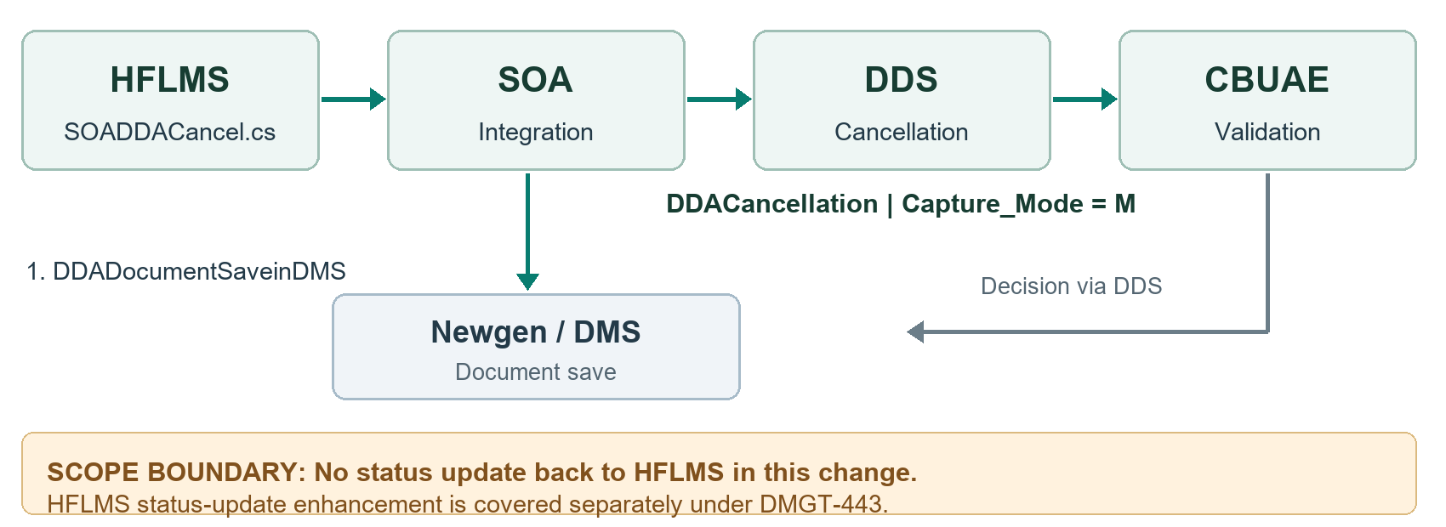
SOA_Calllog_core.method_name | Technical check
DDADocumentSaveinDMS | Confirm document-save outcome and correct DMS/case association.
DDACancellation | Inspect outbound request: Capture_Mode = 'M'; correlate lead_no with DDS result. Empty attachment does not alone imply failure in M mode.
Only the parameter change is covered. Document retention and upload requirements remain subject to existing bank controls. The diagram is a logical support view, not an implementation of callback/status propagation.

4. Read-only verification queries
A. Confirm the configured value; expect the intended effective row with DisplayValue = 'M'.
SELECT DisplayValue
FROM FRM_GNARR
WHERE value = 'DDA_CANCELLATION_CAPTURE_MODE';
B. Retrieve incident-window cancellation calls (the source query's trailing comma is removed).
SELECT lead_no, method_name, Createdon_date
FROM SOA_Calllog_core
WHERE UPPER(method_name) = 'DDACANCELLATION'
AND Createdon_date >= <approved_start_time>
AND Createdon_date < <approved_end_time>;
Query B is a template, not executable SQL as written. Have the DBA substitute typed/bound timestamps using the actual engine syntax and confirm timezone, schema, index and execution cost. Reuse its window for DDADocumentSaveinDMS when tracing a case.
To verify tag M: use the approved SOA log viewer to inspect the outbound DDACancellation request for <Capture_Mode>M</Capture_Mode>. A direct payload query requires the confirmed request-payload column/type and XML namespace; these were not supplied. Neither query above proves the emitted XML value.

5. Ownership and handover record
Role | Contact
Developer / SME / Tester | Sneha / Hariprasath / Abhishek
Platform owner / Scrum Master | Raheel / Muni kumar
Product Owner | Aswathi, Talha
SP&BA / Requirement Owner | Basant / Shahzad

